MAPLFLUENCE
A Spatial Planning & Decision Platform

Executive Summary
Maplfluence is a planning-first spatial intelligence platform developed by Clark & Enersen to help institutions understand, test, and communicate space decisions. It transforms existing facility data into interactive maps, true-to-scale floorplans, and scenario-based views that leadership can immediately understand.
Unlike traditional CAFM systems that focus on operational transactions, Maplfluence focuses on insight, alignment, and future-state decision-making. It complements existing systems today while remaining architected for optional expansion into CAFM-adjacent capabilities over time.
Maplfluence delivers high strategic value with low institutional risk, providing clarity without locking institutions into rigid platforms.

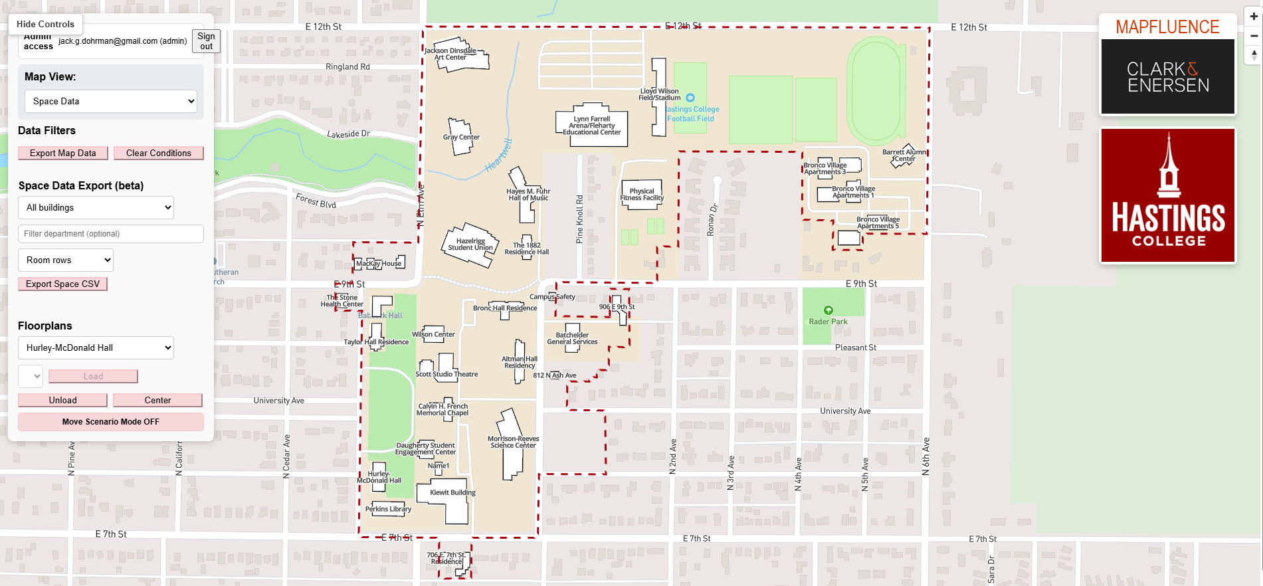

The Challenge Institutions Face
Most institutions already maintain facility databases, CAFM platforms, and floorplans. Yet leadership still struggles to visualize space, evaluate change, and align stakeholders.
The problem is not data availability—it is spatial understanding.
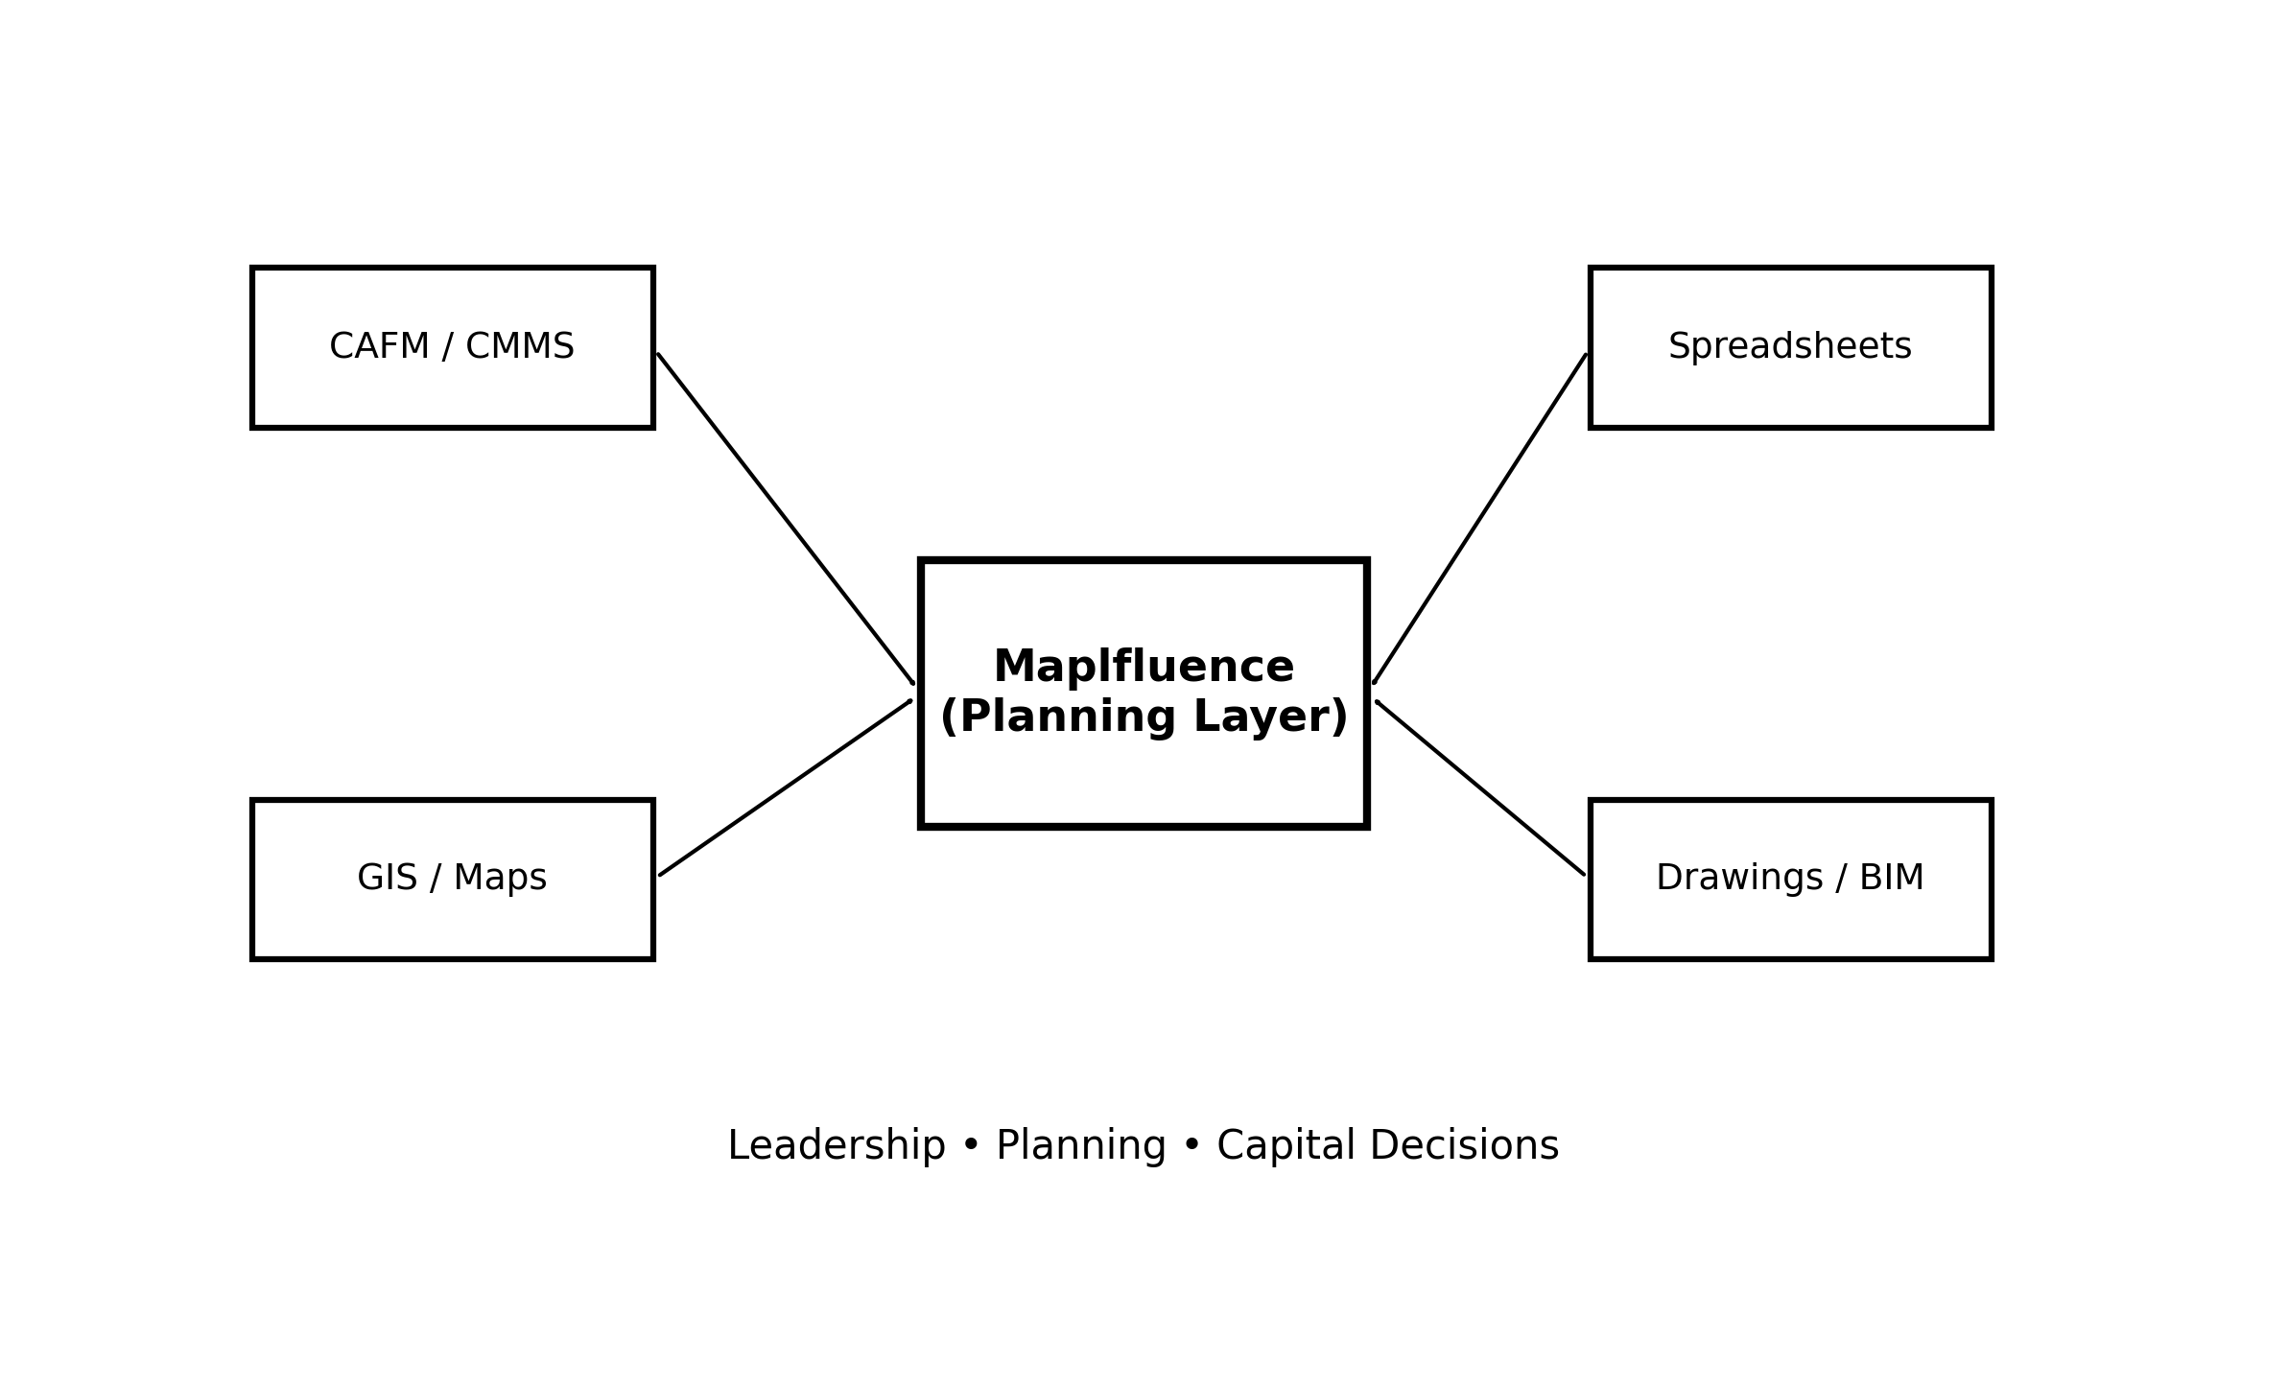

What Maplfluence Is
Maplfluence is a browser-based spatial intelligence platform that elevates facility data into interactive, visual decision tools. It is designed for planners, architects, leadership, and analysts—not just technical users. 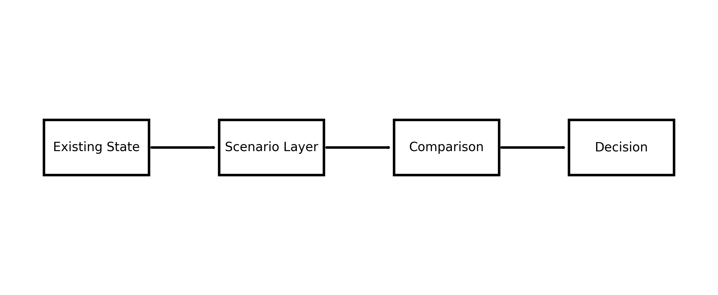

How Maplfluence Fits with Existing Systems
Maplfluence is designed to complement existing CAFM and CMMS platforms. It translates records and attributes into spatial insight and supports planning workflows that operational systems are not optimized to handle.
The platform is intentionally extensible, allowing institutions to expand capabilities over time without committing upfront.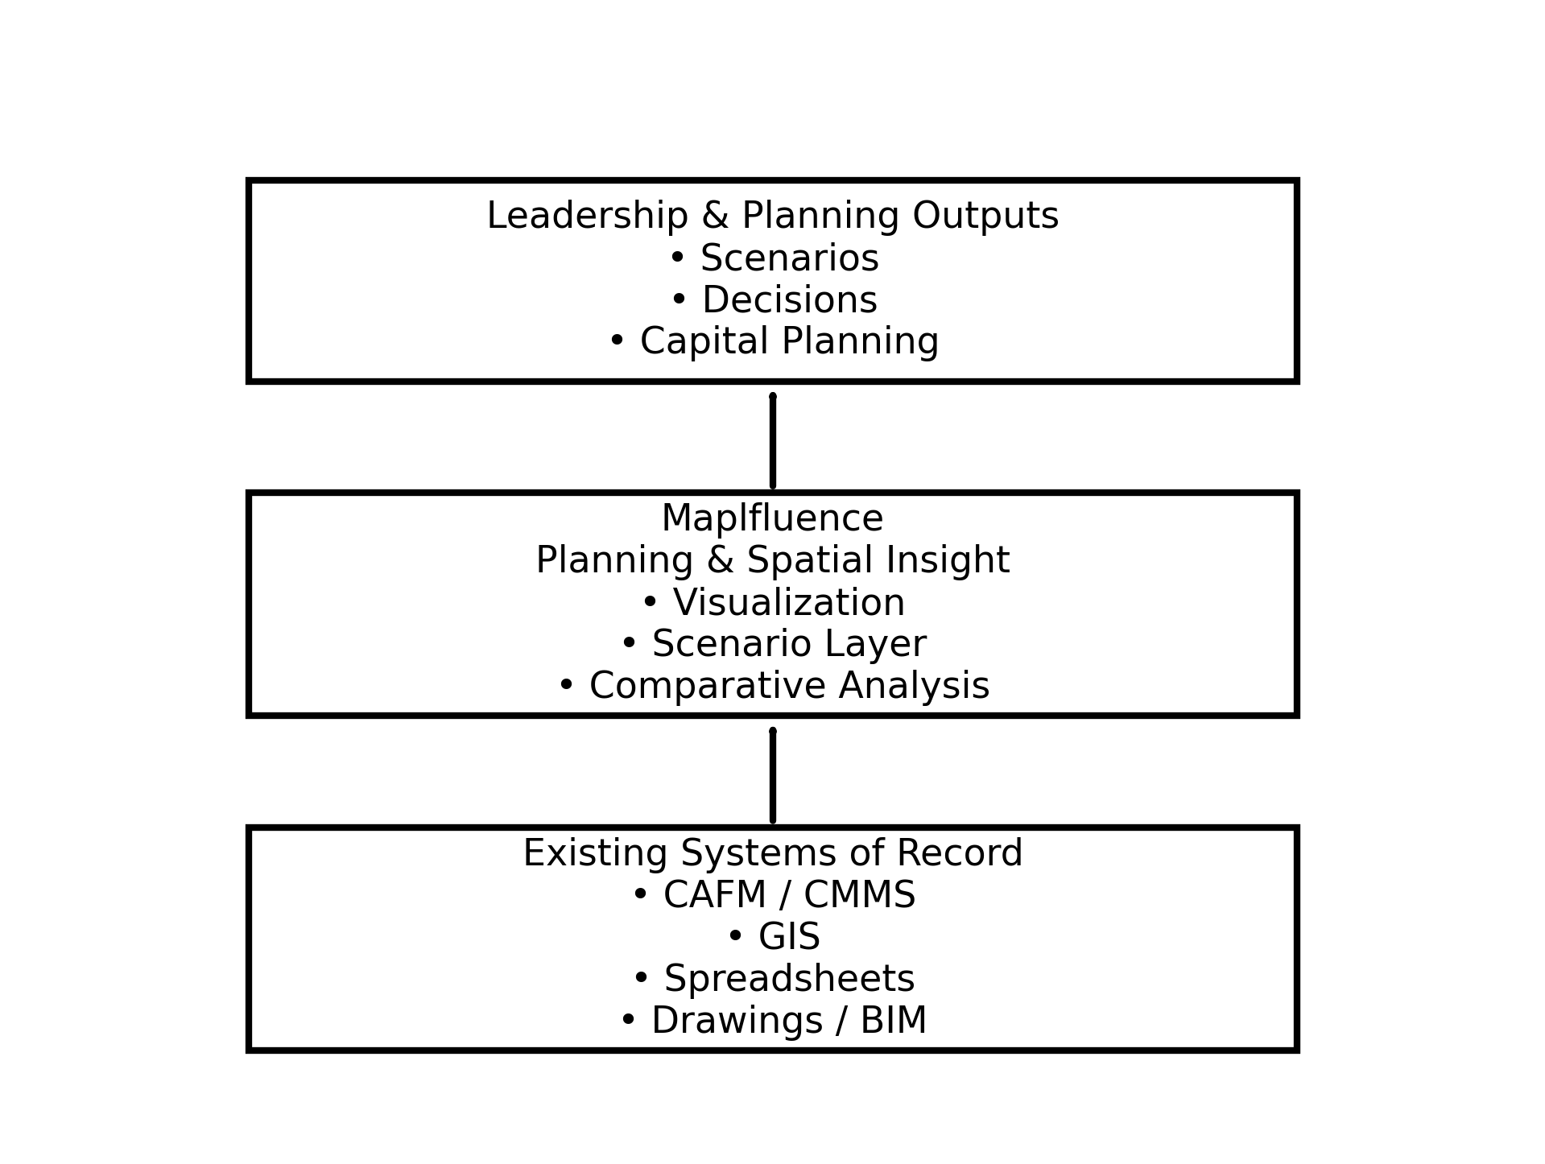

Software Longevity & Risk
Maplfluence is built on open technologies, avoids proprietary data lock-in, and allows full data export. It is not a mission-critical operational dependency, which significantly reduces long-term risk.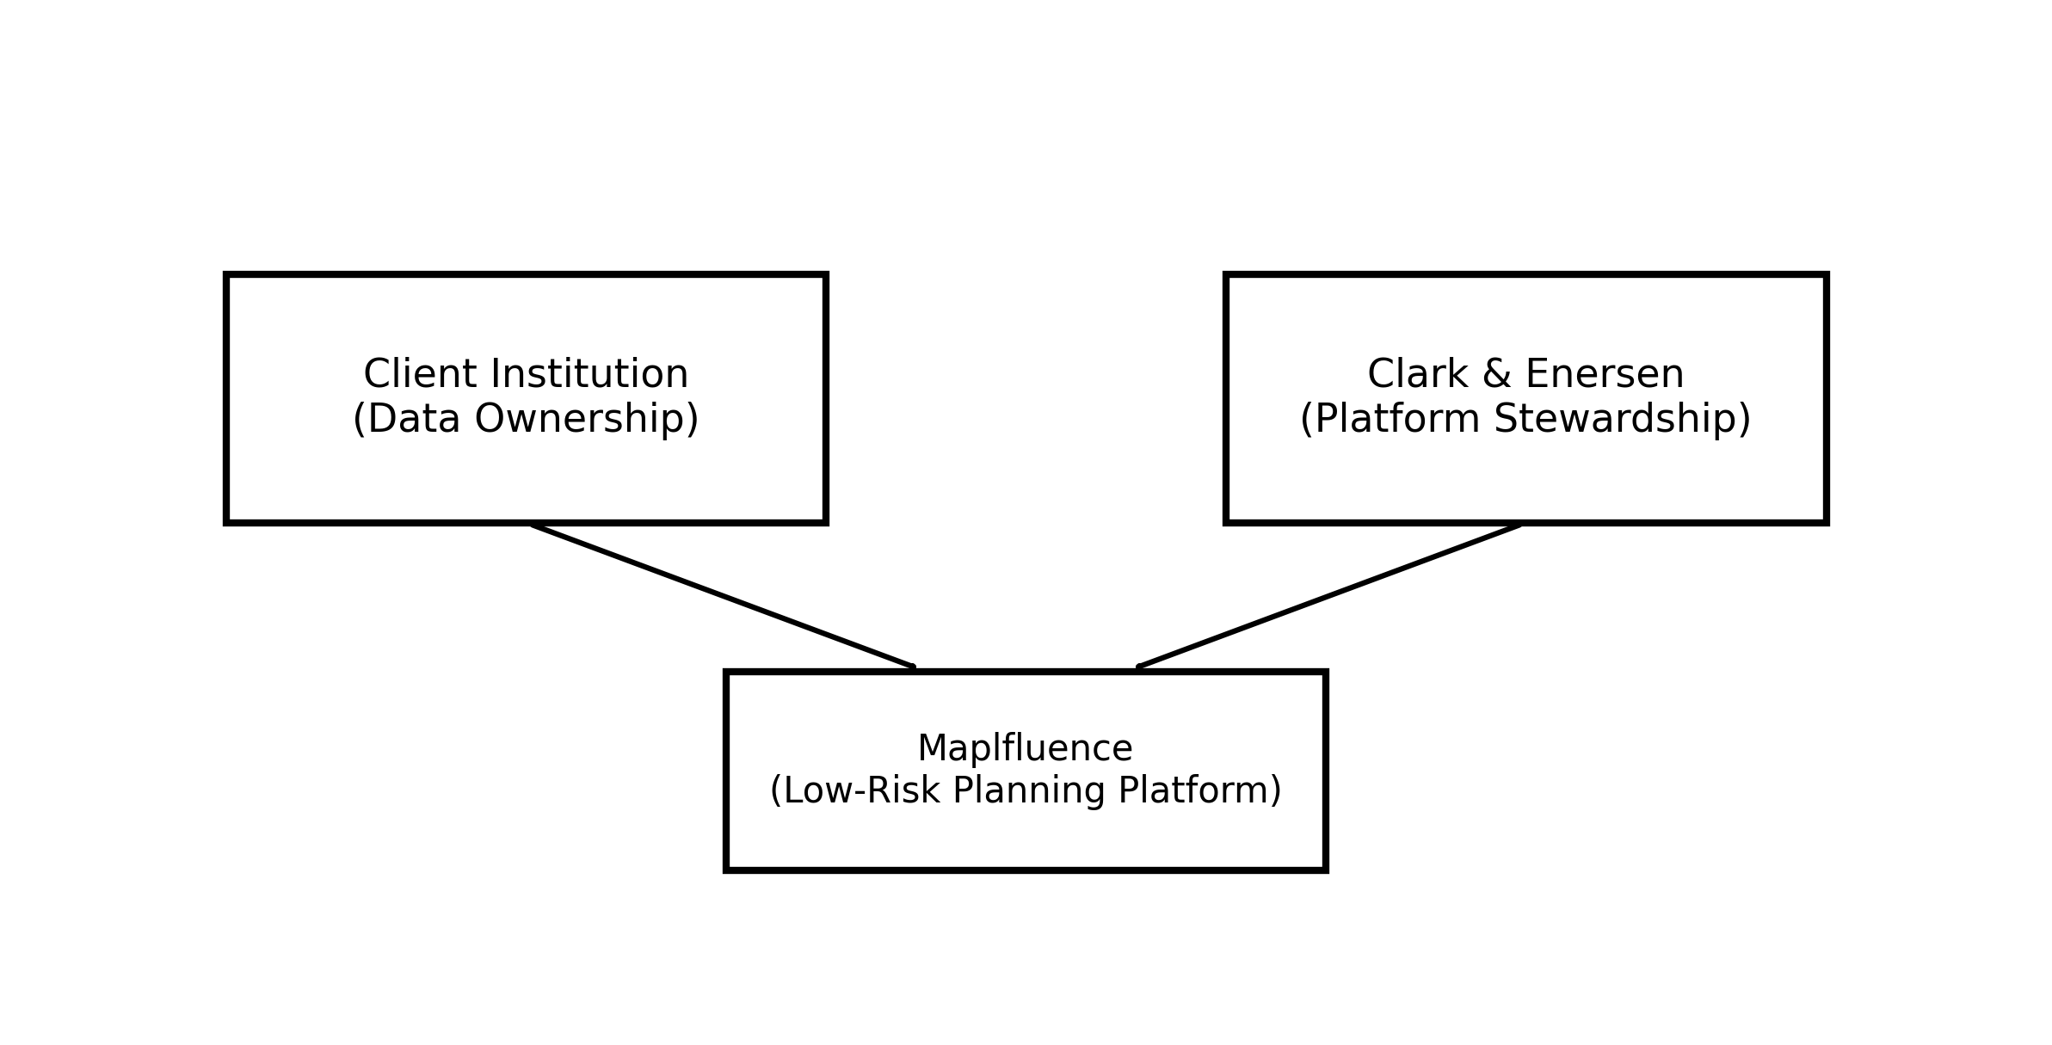

Why Clark & Enersen
Clark & Enersen brings deep experience in planning, architecture, and institutional strategy. Maplfluence evolves alongside real planning needs, governed by professional standards and long-term stewardship. 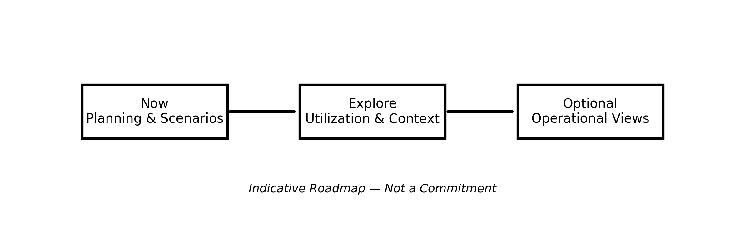

Roadmap (Indicative, Non-Commitment)
Future areas of exploration may include:
• Enhanced utilization analytics
• Asset-context visualization
• Operational data overlays
• Deeper integration with maintenance or lifecycle systems
All roadmap items are evaluated based on institutional value and are not commitments.

